Press Kit Contents
- Press Release
- Book Profile and Cover Photo
- Book Reviews
- Author Profile and Headshots
- Story Ideas
- Recent Press

For Immediate Release

Award-Winning Author Jake Eagle Releases
ReRight Your Life, An Introduction to Reology

New book introduces a new way to create happiness and healthier relationships

May 1, 2013—Santa Fe, New Mexico: ReRight Your Life, An Introduction to Reology (ISBN 978-0-9841362-2-3, paperback, 206 pp., 6 x 9, $14.95) introduces readers to a new way to create happiness and healthier relationships. Jake Eagle, a licensed psychotherapist, tells a moving personal story as a guide for learning, which unfolds through a riveting dialogue between Eagle and his terminally-ill brother. In ReRight Your Life, Eagle explores the meaning of life, behavior patterns that hold people back, the process of individuating, ways to discover personal values, and a new way to speak to ourselves and others. These concepts provide a solid introduction to Reology, the art and science of learning how to be happy.
“I promise you this book will answer your questions—in a substantive way—about how to live a more meaningful life, how to create healthy and intimate relationships, and how to reduce your anxiety,” explains Jake Eagle, co-founder of Reology.org.
This second edition of the book, previously published as Speak Love Not War, contains new insights and discoveries made throughout the last three years of Eagle’s work in private practice and on worldwide personal growth retreats. ReRight Your Life incorporates clear examples of how Reology works in everyday life. It emphasizes the point that life is precious and people can choose what to do with it. Eagle offers readers practical tools and considerations to help improve communications, relationships, and their lives.
“Reology presents a new language, ReSpeak, making a unique contribution to the field of personal development—possibly the most significant advancement in human consciousness since the days of Freud. Use the simple and profound language tools in this book and you will soon discover a perspective that transforms your internal life and relationships in remarkable and unexpected ways,” states Mike Bundrant, co-founder of the iNLP Center and host of Mental Health Exposed, a Natural News Radio program.
To purchase a copy of ReRight Your Life, An Introduction to Reology, please visit http://reology.org or call (505) 986-3922.
About Jake Eagle
Jake Eagle is a licensed psychotherapist, award-winning author, and co-founder of Reology.org, an educational organization dedicated to improving relationships and lives by fundamentally changing the way people relate to themselves and others. Jake and his wife, Hannah, have been happily married for more than twenty years. They live and work together in Santa Fe, New Mexico, and lead Reology Retreats all over the world.
About Reology.org
Reology.org is an organization and community dedicated to improving relationships and lives by fundamentally changing the way people relate to themselves and others. Promoting the benefits of Reology, the art and science of learning how to be happy, Reology.org provides its community of readers and practitioners with educational materials and programs that help to guide the processes of self-discovery, personal growth and maturity. For more information, visit http://reology.org or call (505) 986-3922.
###

About ReRight Your Life, An Introduction to Reology
This award-winning book will give you an introduction to Reology and tools you can use to Re-Right your life, right here and right now. It’s written is an easy-to-read style as a conversation between Jake Eagle, a licensed psychotherapist, and his brother. ReRight Your Life explores the meaning of life, core-limiting patterns that hold us back, the process of individuating, ways to discover your values, and a new way to speak to yourself and other people. This book was previously published as Speak Love Not War, and although much of the content is the same, this new edition introduces the reader to Reology, the art and science of learning how to be happy, as well as some updated chapters.
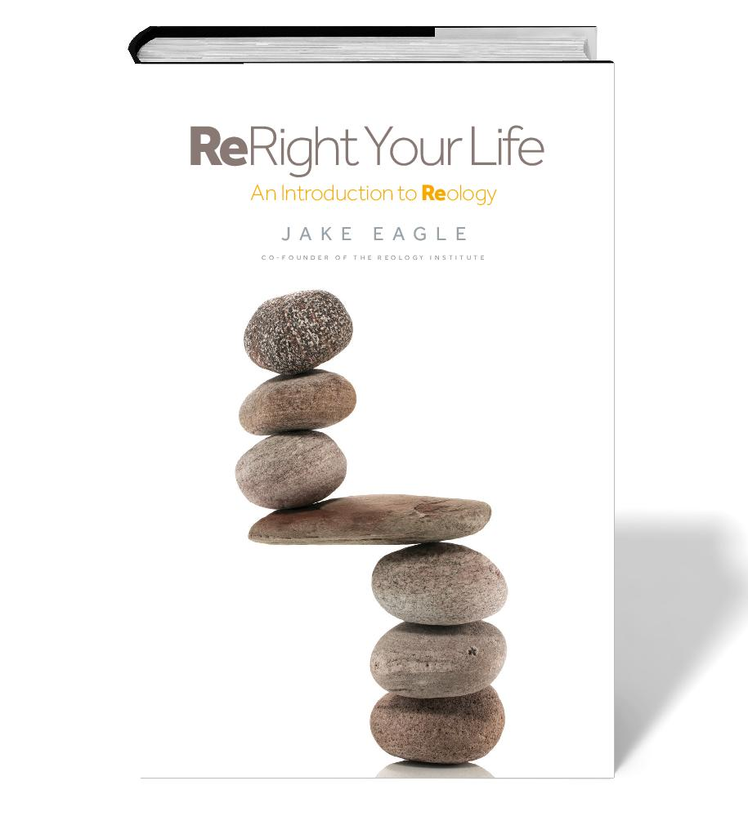

Book Reviews
Mike Bundrant: Jake Eagle has introduced a truly surprising and fresh new approach to psychology, which he calls Reology. Through his personal experience and tragedies, I can feel Jake’s commitment to this new paradigm of radical respect for the “emotional footprint” we all leave behind in our interactions with ourselves and others.
Many books claim to offer a new paradigm for personal development, but few offer the tools that honestly deliver the new paradigm into the mix of daily life and struggles. The key here is ReSpeak, a new way of using language that transforms your experience in the very act of putting it into words. The language seemed a bit awkward at first, but soon sunk in. As I have pondered my life using ReSpeak and shared it with my wife and a few friends, we have been impressed with how it changes our feelings, especially when it comes to tense or potentially conflictual interactions. My 16-year-old son even commented, “Dad if everyone at school used this language, 90% of the problems on campus would vanish.” Personal responsibility, empowerment and respect for others are simply built into the structure of communication with no additional effort required! This is an elegant solution that I have never encountered anywhere.
Well done, Mr. Eagle. I will be passing this along to as many people as I can.
Mike Bundrant, Publisher, Healthy Times Magazine, Radio Talk Show Host of Mental Health Exposed

Jobie Summer: There are many great philosophers and teachers out there but the way Jake Eagle connected this book with his personal journey made it so delicious to read. He wrote this book as a conversation with his brother and personalized it so beautifully that it brought realness and relevance to the movement of Reology. As you read this book you will not only learn the theory of Reology but you will see how ReSpeak (the language of Reology) transforms relationships right before your eyes. What a precious, graceful way to teach the essence of ReSpeak.
I engaged myself so deeply in the teachings and in the closeness I felt to Jake and to his journey that I continued reading until I was done. I couldn’t put it down and finished it in one day. The book has taken the work of Reology to the next level and makes it so approachable and understandable. This book is truly life changing.
I recommend this book for those who are ready to truly embrace their zest for life. The teachings of ReSpeak are about taking full responsibility for ourselves and our actions and it all starts with our use of language. May you enjoy this book and may it bring exponential growth to your life as it has for me.
Jobie Summer, Marketing Strategist

William Underwood: This is a great read. Particularly, if you’re interested in learning about what it takes to live fully, assume complete accountability for your actions, reactions, and well-being. Through an intimate dialogue with his ailing brother, Jake explains Reology in a very accessible manner. In his conversations with his brother, I clearly appreciate the idiom – “you are what you say.” Jake describes Reology in everyday language, and demonstrates how our everyday use of language can cause us to disassociate ourselves from owning our own reactions and feelings. I find his connections between semantics and sanity come from a similar linage as Korzybski’s Science and Sanity, however, ReRight Your Life takes another step toward clarifying just how our talk affects what we experience; and how the way say we speak affects the way we relate to others and to the world.
William Underwood, CEO, Catalyst Consulting
Mary Waldner: Various schools of psychology have talked for a long time about taking personal responsibility for one's feelings and for one's life. Yet when psychotherapy is actually practiced, so much emphasis is placed on the exploration of one's feelings as the path towards freedom from one's conditioning that the client doesn't really learn to take the next step in relationship to feelings—to observe and contain and truly own one's reality as just your own. Our everyday language allows us to continue to project responsibility of our feeling states onto others—"he makes me sad" or "it angered me"—keeping us in the passive role.
ReSpeak language, as taught by Jake and Hannah Eagle, offers a communication practice and a life perspective that truly liberates us from the tyranny of taking responsibility for other's feelings and from the burden of staying stuck in our own feelings as well. They offer a simple and powerfully effective language style woven into a deep understanding of human development that allows us to observe and move through long standing feelings, making room for joy, play and love.
Mary Waldner, Chairman & Founder, Mary's Gone Crackers. Waldner, also, a licensed marriage and family therapist for 26 years

About Jake Eagle
Jake Eagle is a licensed psychotherapist, award-winning author, and co-founder of Reology.org, an educational organization dedicated to improving relationships and lives by fundamentally changing the way people relate to themselves and others. Jake and his wife, Hannah, have been happily married for more than twenty years. They live and work together in Santa Fe, New Mexico, and lead Reology Retreats all over the world.
Leading groups and working with individuals for more than 35 years, Jake works in a unique style that is pragmatic and grounded, but also illuminates each person’s health and potential. He has come to believe that people often accomplish more growth in a weeklong retreat than in years of individual therapy. He says, “Such immersion is often the best way to free ourselves from habitual behaviors, and to learn a new, healthier way to live our lives.”
Jake’s life journey is an example of pursuing one’s passions. After sixteen years of running small businesses on the east coast, Jake recreated his life by moving to New Mexico and becoming a psychotherapist. His years in business influence his approach to therapy. In the late 1990′s, Jake’s focus shifted from brief therapy to deep therapy, the purpose of which is psychological integration. This new direction was advanced after he met his mentors, John and Joyce Weir, creators of a method known as Percept, which has now evolved into Reology. Today, Jake helps clients focus not only on personal growth and learning how to relate with others in healthy ways, but also on finding meaningful work and creating financial stability.
The practice of Reology leads to sustainable growth, allowing people to build stronger foundations within themselves. These foundations then support lives of greater ease and grace.
Jake’s award-winning book, ReRight Your Life, helps readers re-discover themselves and re-right their lives when faced with personal circumstances, challenges, and crises. ReRight Your Life is available in print or e-book format on Reology.org, Amazon.com and other e-tailers. For more information, please visit Reology.org or call (505) 986-3922.
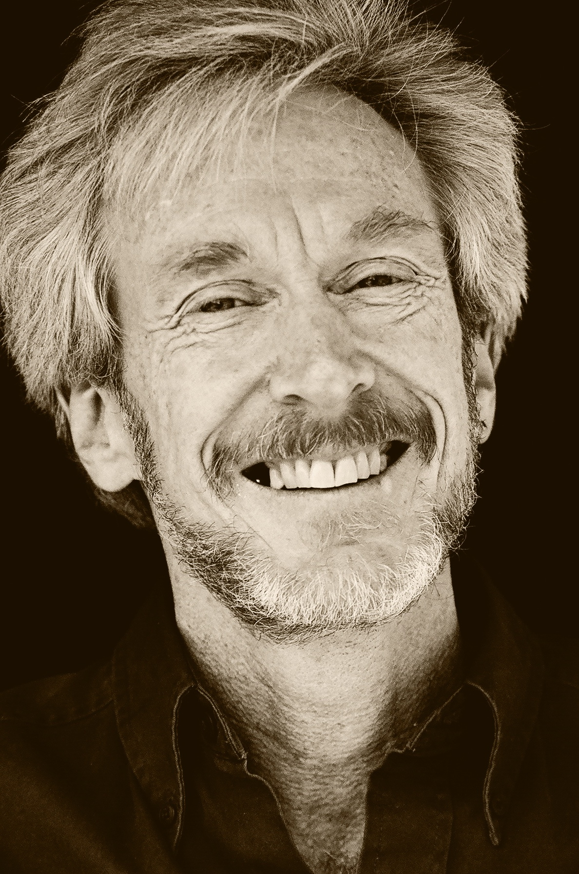
Jake Eagle

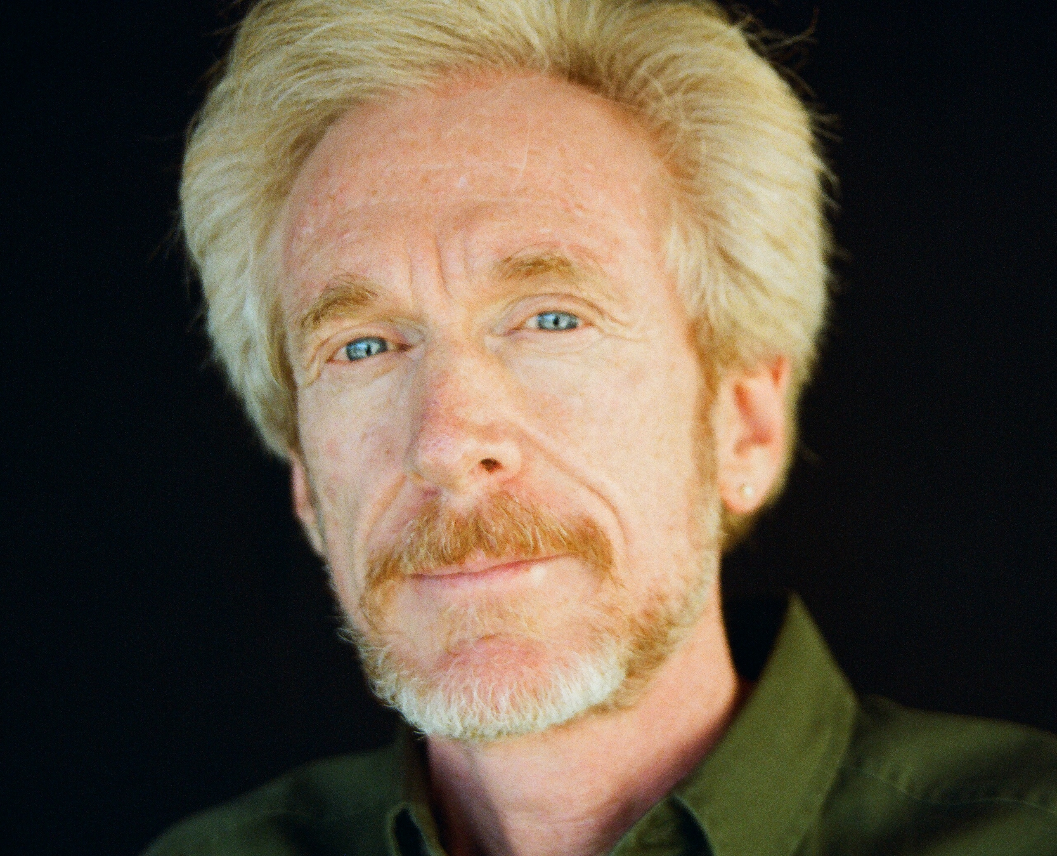
Jake Eagle

Story Ideas

Relationships
- How Secret Thoughts Trick You into Hurting Your Relationships ... and How to Stop Them Dead in Their Tracks.
- Is Fear of Intimacy and Love Destroying Your Relationship? 3 Ways to Stop It Now.
- Why Money Issues Always Derail Your Relationships… and 8 Ways to Resolve Them Today.

Aging
- 5 Life-Affirming Goals Missing from Your Bucket List
- 4 Secrets Every Woman Needs to Know to Age Gracefully and Beautifully
- Grey Divorce: The Top 3 Reasons Aging Couples Grow Apart

Happiness/Depression
- 3 Secret Happiness Tools Guaranteed to Turn Your Frown Upside Down
- How to Identify Your Depression Triggers…and Get Rid of Them Once and For All

Death and Dying
- 8 Ways to Face Your Fear of Death and Dying
- The Best Way to Deal with Grief After the Loss of a Loved One

Recent Press
Wall Street Journal | Reology.org Teaches How to Be Happy: New website offers guidance and resources to live a happier life.
http://online.wsj.com/article/PR-CO-20130501-909100.html?mod=googlenews_wsj

PsychCentral | Can You Re-Do Your Life? A Brief Review of Reology.
http://blogs.psychcentral.com/nlp/2013/04/can-you-re-do-your-life-a-brief-review-of-reology/

